**Effects of Album Reviews on Consumers**

**Jesse Ventura**

**Abstract:**

There are currently more reviews on products than ever before. With the increased availability of information due the internet, more consumers are reading online reviews about products and services to gauge if that service or product is worthwhile. Currently certain industries, such as the film industry, are advertising these reviews to generate more success for their upcoming films. However, industries such as the music industry, do not know the effects that these reviews bring. In this paper I will discover, using a survey consisting of University of Maryland students, if music reviews have an influence on consumers. The results concluded that consumers are not very influenced from music reviews in general however, consumers are slightly more influenced by consumer reviews than editorial reviews.

**Introduction:**

With the internet came the increase of readily available information. Such information was very helpful for consumers in understanding if a product was for them or not. This principle was then centralized to create product reviews. In 1995 Amazon began allowing consumers to leave comments on their page about products they had just purchased. Those reviews are regarded as one of the most successful features of the Amazon website. (Harmon, 2004).

Since then more and more platforms for online reviews have emerged. Different industries now have a variety of channels that consumers can use to evaluate their probability of buying a product or service. Currently many industries have allowed the option to write experience reviews right on the industry website. With all the reviews that have emerged, many industries are trying to understand the effects that these reviews bring. This paper will be looking at the effects of reviews in the music industry specifically.

To understand the effects of reviews in the music industry it is important to separate the two different types of reviews that currently exist. The two different types of reviews are consumer reviews and editorial or critic reviews.

Consumer reviews are considered word-of mouth reviews [WOM]. In other words, consumer reviews are any reviews by non-editors that are posted anywhere. This includes blog websites, social media, as well as day to day conversation. Editorial reviews are reviews that are posted by experts in their respective fields who are paid for their opinion on a product or service. With this new age of technology, most WOM reviews are done online versus traditionally. However, most online consumer reviews have lower credibility due to the absence of source cues on the internet (Smith et al., 2005; Dellarocas, 2006). Although the credibility of online WOM is not very high, WOM in general strongly influences consumer’s decision-making process as concluded by Goldenberg et al. (2001). This paper will aim to find the effects of both the consumer reviews as well as the editorial reviews in the music industry.

Studies have been done that aid in finding the answer to the effects of music reviews. An industry that has had many studies done that aid in the finding of this answer is the movie industry. The reason for why the movie industry has had many studies done is because some film studios have begun advertising their editorial reviews in hopes of generating box office success. However, the question remains, do these movie reviews actually influence consumers.

A good way to gauge if these movie reviews influence consumers is to see if there is a correlation between film criticism and movie earnings. This was exactly what Eliashberg and Shugan (1997) decided to do and their results were interesting. According to them, they found a positive correlation between film criticism and cumulative earnings in the American market. However further examination of their results revealed that this relationship only became positive after five weeks of the movie being released. This means that critical reviews are more of means of predicting the success of a movie rather than influencing consumers to actually go see a movie. This same aspect of reviews could be used for editorial music reviews.

Another studied conducted by Hirshman and Pieros (1985) discovered that there was a negative relationship between the earnings of selected films and their critical evaluation. The reason for film criticism not being an influencer on the box office success can be attributed to the difference in taste of film critics versus the taste of the general public. According to Hollbrock (1999) critics like abstract and complex artwork while the ordinary consumer likes more understandable and accessible means of artwork.

The general consensus on the impact of critical movie reviews is that it does not influence the consumer to watch a movie. From this it can be inferred that, like movie reviews, music reviews may yield the same impact. However, it is important to not just look at the impact of editorial movie reviews and decide the same should be said for editorial music reviews. Examination of the influence of other product or service reviews in similar industries could also help gauge the impact of music reviews.

An industry that has some similar qualities of the music industry is the tourism industry. Both music and traveling offer an experience, thus their product could be considered an experience good. To examine if music reviews have an influence on consumers it is beneficial to find out how often do consumers look at reviews. According to Gretzel and Yoo (2008) around three-quarters of travelers looked at online reviews, as a source of information, when planning trips. This shows that when it comes to industries that provide an experience, such as tourism, it is more than likely that a consumer would look at a review. Music is considered by some to generate an experience thus from this study we can infer that music reviews might be viewed as often as travelers looked at online reviews.

The music industry is also considered to be a part of the entertainment industry. To understand the influence of reviews on music we should look at similar studies done in the entertainment industry. A study conducted by Zhu and Zhang (2006) concluded that online consumer reviews have a significant influence on the sales of video games. Gaming is a part of the entertainment industry, thus from this study it can be hypothesized that music reviews have a similar influence on consumers.

We can conclude from the studies conducted by Gretzel, Yoo, and Zhu, Zang that consumer reviews in the tourism and gaming industry have an influence on consumers. Studies done in the movie industry show critic reviews do not influence the consumers. The outcomes of these studies however, cannot be directly applied to the impact of music reviews on consumers just because they are in similar industries. Different factors could change what the effect of music reviews will be. Nonetheless, these studies act as a stepping stone into the impact of music reviews.

The impact of music reviews should be studied as often as the impact of movie reviews. The reason why is because the growth in the music industry over the past couple of years has increased. In this new digital world there are many platforms that allow music to be readily available in all parts of the world at any time. With the increase flow of music being produced it can be hard for a consumer to choose what artist or music would be the most preferable. If positive music reviews influenced consumers to listen to an album, then record labels could begin advertising their music in order to get the consumer to listen to that album. This would be beneficial for the record label but also for the consumer. Record labels would generate more profit and the consumer would spend less time looking for a preferable artist and instead go to the music that was critically appraised. For this reason, this study has an urgency to be done now more than ever before.

**Methods**

In order to understand how much of an influence album reviews have on consumers, research should be done on those who listen to music more than anybody else. According to statista.com those aged between 18-24 listen to music everyday more than any other age group. At the University of Maryland most college students fit into this age group. Thus, conducting a survey consisting of University of Maryland students was ideal for this topic.

Next, a series of questions was created that would help determine what effects album reviews have on consumers. Those questions are as follows:

1. How often do you listen to music?

-The reason for this question was to gauge how often do the students being surveyed listen to music. The importance of that aspect shows if the data being received should be valued or not.

1. How often do you view Music Reviews?

-The reason for this question is that shows if the survey pool actively looks at music reviews. This will give insight as to if there is a correlation to the study conducted by Gretzal and Yoo that concluded experience goods, like tourism, had reviews that were viewed by three fourths of planning travelers.

1. If a recent album gets a good review score are you more likely to listen to it?

-This question shows if the effects of a positive editorial review on consumers is positive.

1. If a recent album gets a bad review score are you less likely to listen to it?

-The reason for including this question is it shows if the effects of a negative editorial review on consumers is negative.

1. Does a good/bad review score affect your opinion on an album?

-The reason for including this question is to see if an editorial review on an album can affect their opinion on an album.

1. Does a good/bad music review score encourage/discourage you from listening to an album?

-The reason for including this question is to see, in general, if an editorial review of an album influences their chance of listening to an album.

1. If your fellow friends or social media give a good/bad review of a recent album does that encourage/discourage you from listening to it?

-This question shows if WOM (word-of mouth) reviews have an influence on consumers. This will help determine whether consumer reviews or editorial reviews influence consumers more. Also, this question gives the opportunity to compare results of WOM review influence to those of Goldenberg et al which state WOM reviews in general strongly influences consumer’s decision-making process

The following statements are hypothesis before conducting the survey.

* Hypothesis 1- A large number of consumers view music reviews.
* Hypothesis 2- Negative editorial reviews will create a large negative influence on consumers.
* Hypothesis 3- Positive editorial reviews will create a large positive influence on consumers.
* Hypothesis 4- An editorial review will not affect a consumer’s opinion on an album.
* Hypothesis 5- An editorial review will affect most consumer’s chance of listening to an album.
* Hypothesis 6- Consumer reviews on an album have an influence on consumers.
* Hypothesis 7- Consumer reviews on an album have a larger influence on consumers than editorial reviews.

The survey was dispersed to students attending the University of Maryland via email. There were 48 responses.

**Results**

The results generated were surprising as well as anticipated. The students surveyed was ideal for the surveyed conducted. 91.84% of the students replied that they listen to music either most of the time or always. This was anticipated due to the statistics found on statista.com. These results verified that this survey pool was ideal for the topic of album reviews.

An interesting result was that a large number of students said they do not view album reviews. 75% of the students answered they never view album reviews with 22.92% answering sometimes. 2.08% answered they always view album reviews. These results contradict previous studies done in the tourism industry. The study conducted by Gretzel and Yoo (2008) concluded that three fourths of consumers looked at online reviews when booking a hotel. However, although music is an experience good similar to tourism, the number of consumers who viewed music reviews was much less compared to tourism reviews. Reasons for such difference can be attributed to the fact that music may not be as reliant on consumer experience as tourism. Tourism reviews have health and safety precautions attached to reviews while music reviews do not have such high implications.

For the music industry these results show music corporations that their consumers do not view music reviews as much as they do in other industries. Thus, when deciding if they want to advertise their critical reviews they should keep in mind that a large percent of their consumers don’t look at those reviews.

The number of students who said they would be encouraged to listen to an album after viewing a positive review score was unanticipated. 45. 83% of students replied they maybe will listen to an album if it gets a good review score. 31.25% replied no and 22.92% replied yes. The small percentage that would have listened to an album review is the percentage that is important to music corporations. Music labels must decide if the small percentage of additional listeners that may come from a good review score is worth the cost of advertising critical review scores. Students were similarly not discouraged from listening to an album because of a negative critical review score. 45.83% answered no a negative review score on an album does not make them less likely to listen to it. 43.75% answered maybe and 10.42% answered yes. Both a negative critical review score as well as a positive critical review score don’t seem to have a concrete corresponding impact on consumers.

Most students’ opinion on an album are not affected by a critical review score. 52.08% said that a good/bad review score does not affect their opinion on an album with 4.17% replying yes. Students seem to keep an opinion on an album regardless of what other outside input they here from experts or critics. It should be stated, however, that this does not correlate on if the student will listen to an album, rather it explains how an opinion on music won’t be swayed by critics.

In general students are not more or less inclined to listen to album after a bad or good critical review score but the evidence is not concrete. When asked if in general does an album review score effect your willingness to listen to an album, most students replied no, however a large portion replied maybe. This indecisiveness makes it hard to give a concrete answer to the effect of critical album reviews. Nonetheless, there is a very small percentage that said yes. This again effects how music corporations will decide if advertising critical reviews is worth the small increase of additional listeners.

The results also indicated that students are much more likely to listen to an album if it is recommended from consumer reviews. 41.67% said they are encouraged to listen to an album if it gets a good consumer review while 27.08% said no. This percentage is of vast contrast to the percentage of students who said they were influenced by editorial reviews. The following pie charts demonstrate the differences in influence of consumer reviews versus editorial reviews.

Figure A Figure B

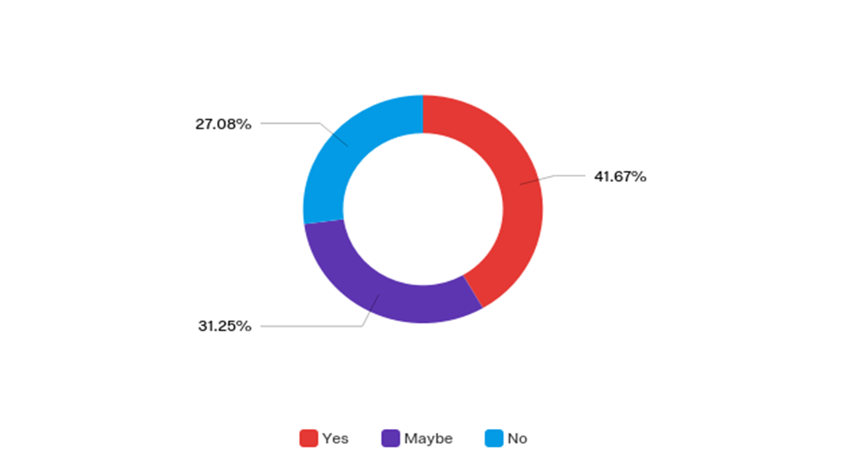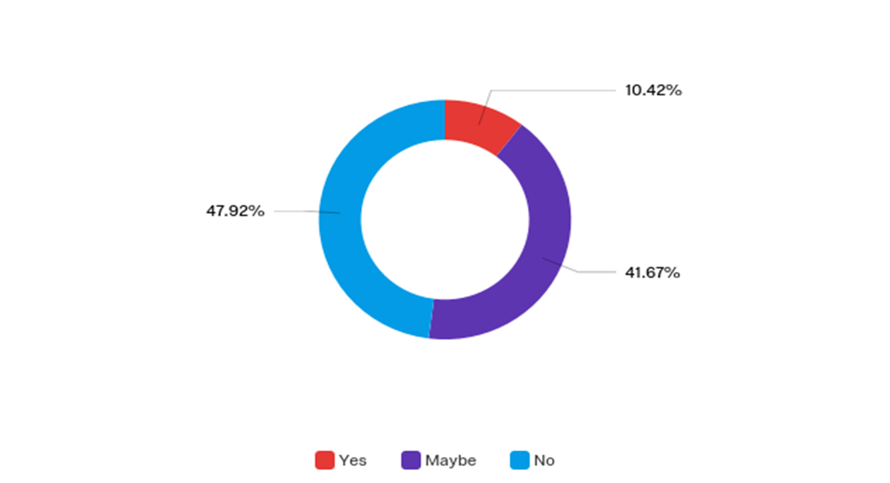

-Influenced by Consumer Reviews -Influenced by editorial reviews

In Figure A we can see that a large portion of students said they were influenced by consumer reviews. In figure B we can see that only a very small portion was influenced by editorial reviews. We can conclude that consumer music reviews have a significantly larger influence on consumers than editorial music reviews. The findings from this study also verifies the study conducted by Goldenberg et al which states WOM reviews in general strongly influences consumer’s decision-making process.

The findings of these results also seem to coincide with the studies done in the movie industries. Both in the movie industries and in the music industry editorial reviews do not seem to garnish an influence on their respective consumers. This can be attributed to the differences in taste between the general public and critics. The difference between these two groups seems to be heightened when the subject is art. Art critics enjoy an abstract or high intellectual content while the general public like more relatable and easy to understand content.

**Conclusion**

Editorial reviews do not seem to hold much weight in the music industry when it comes to the consumers. Negative or positive editorial reviews do not seem to have a corresponding influence on consumers. Also, editorial reviews in general do not seem to have much influence on consumers. However, there is a very small portion of consumers who are influenced by editorial reviews and music corporations should take into account if those small number of additional listeners are worth the advertising cost of advertising music reviews.

Consumer reviews are much more valued by consumers in the music industry. Consumer reviews are more likely to influence a consumer to listen to an album. This can be attributed to the new age of information in which any person with a social media account can give their criticism of an album and have it read by a friend. This expansion of interaction amongst peers creates a type of higher influence between peers than between a consumer and a critic.

Music corporations would be able to benefit much more if they were to advertise consumer reviews. However, it would be very hard to implement such a system because most music consumer reviews are being done via social media and only influencing those who follow said reviewer.

Not only do these findings bring feedback to the music industry, but they also bring feedback to the movie industry. This study seems to correlate with similar studies done in the movie industry. Film studios may want to reconsider if the advertisement costs of advertising movie reviews are worth the low influence it has on its consumers.

Limitations to this study include the low number of responses, age group, and genre of music. A higher survey pool might yield much more accurate results. Also, the age group restriction to only college students may not give an accurate description of the influence of music reviews for the entire population. This survey also did not categorize the information based on the genre of music. Music reviews could have higher or lower levels of influence based on the genre of music they are in.

**References**

Dellarocas, 2006 C. Dellarocas “Reputation mechanisms” T. Hendershott (Ed.), Handbook on Information Systems and Economics, Elsevier Publishing, New York (2006), pp. 629-660

Eliashberg, J., & Shugan, S. M. (1997). “Movie Critics: Influencers or predictors?” Journal of Marketing, 61(April), 68–78.

Goldenberg et al., 2001 J. Goldenberg, B. Libai, E. Muller “Talk of the network: a complex systems look at the underlying process of word-of-mouth” Marketing Letters, 12 (3) (2001), pp. 211-223

Harmon, Amy. “Amazon Glitch Unmasks War Of Reviewers.” The New York Times, The New York Times, 14 Feb. 2004, www.nytimes.com/2004/02/14/us/amazon-glitch-unmasks-war-of-reviewers.html.

Hirschman, E., & Pieros, A. (1985). Relationships among indicators of success in Broadway plays and motion pictures. Journal of Cultural Economics, 9(1), 35–63.

Holbrook, M. B. (1999). Popular appeal versus expert judgments of motion pictures. The Journal of Consumer Research, 26(2), 144–155.

“Music Listening Habits in the U.S. by Age 2017 | Statistic.” *Statista*, www.statista.com/statistics/749666/music-listening-habits-age-usa/.

Smith et al., 2005 D. Smith, S. Menon, K. Sivakumar “Online peer and editorial recommendations, trust, and choice in virtual markets” Journal of Interactive Marketing, 19 (3) (2005), pp. 15-37

U. Gretzel, K. Yoo “Useandimpact of online travel reviews” P. O’Connor, W. Höpken, U. Gretzel(Eds.), Information and Communication Technologies in Tourism 2008, Springer-Verlag, Wien/New York (2008), pp. 35-46

Zhu and Zhang, 2006 F. Zhu, X. Zhang “The influence of online consumer reviews on the demand for experience goods: the case of video games”Proceedings of 27th International Conference on Information Systems, Milwaukee, December (2006), pp. 367-382